DAY 7 :- TestNG

**TASK 01:-**

package com.day7;

import org.openqa.selenium.WebDriver;

import org.openqa.selenium.chrome.ChromeDriver;

import org.openqa.selenium.chrome.ChromeOptions;

import org.testng.Assert;

import org.testng.annotations.Test;

import io.github.bonigarcia.wdm.WebDriverManager;

public class task1 {

@Test

public void method1() {

WebDriverManager.chromedriver().setup();

ChromeOptions co=new ChromeOptions();

co.addArguments("--remote-allow-origins=*");

WebDriver driver=new ChromeDriver(co);

driver.get("https://demo.wpeverest.com/user-registration/guest-registration-form/");

String actualtitle=driver.getTitle();

String expectedtitle="Guest Registration Form-User Registration";

Assert.assertEquals(actualtitle, null);

}

}

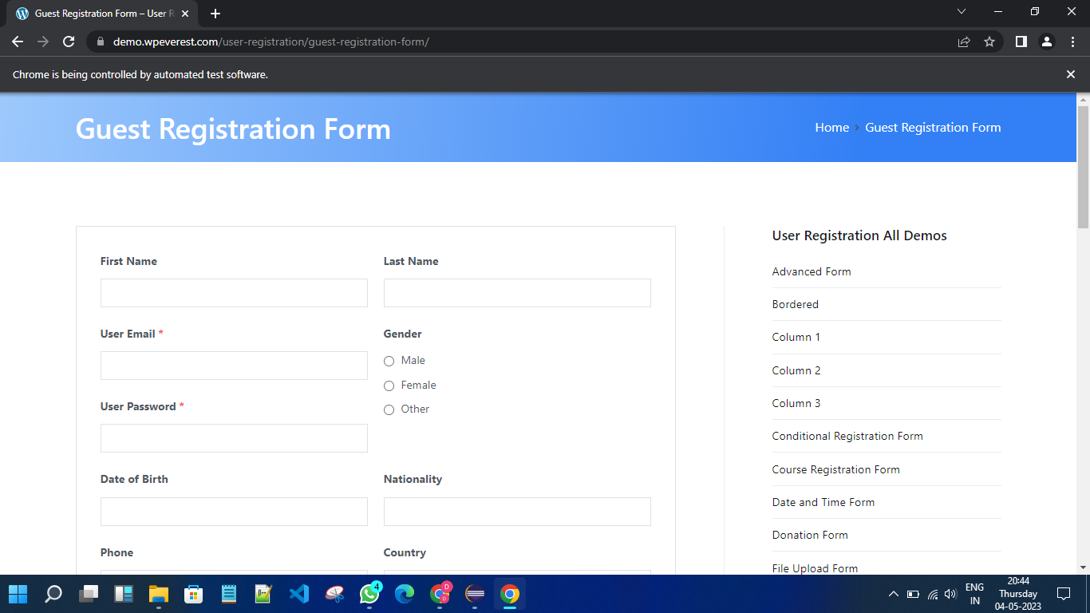

**TASK 02:-**

package com.day7;

//import java.util.Scanner;

import org.testng.Assert;

import org.testng.annotations.BeforeSuite;

import org.testng.annotations.Test;

public class task2 {

int a,b,c;

@BeforeSuite

void getdata(){

a=7;

b=4;

}

@Test(priority=1)

public void add() {

c=a+b;

Assert.assertEquals(c,11);

}

@Test(priority=2)

public void sub() {

c=a-b;

Assert.assertEquals(c, 3);

}

@Test(priority=3)

public void mul() {

c=a*b;

Assert.assertEquals(c, 28);

}

@Test(priority=4)

public void div() {

c=a/b;

Assert.assertEquals(c, 1);

}

}

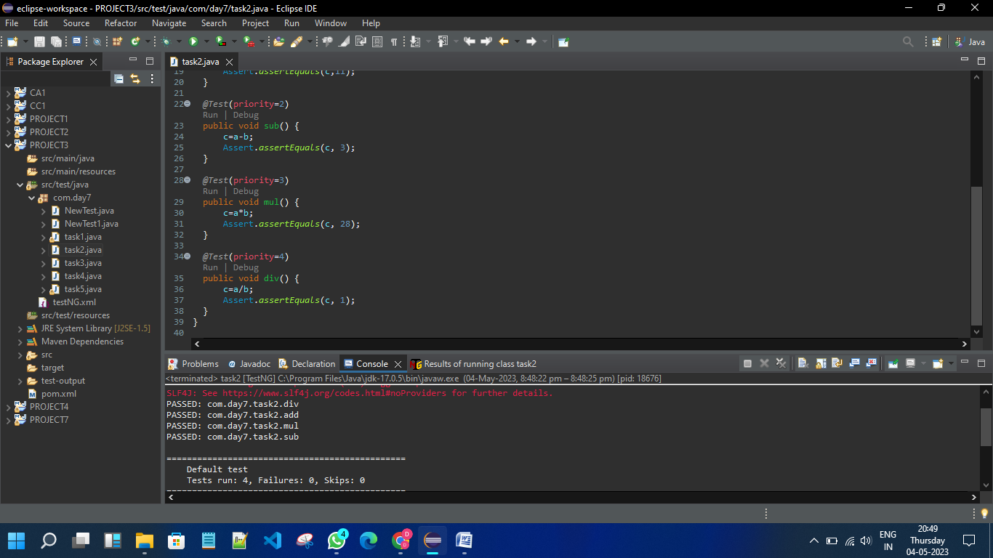

**TASK 03:-**

package com.day7;

import org.testng.annotations.Test;

import io.github.bonigarcia.wdm.WebDriverManager;

//import io.github.bonigarcia.wdm.WebDriverManager;

import org.testng.annotations.BeforeMethod;

import org.testng.annotations.AfterMethod;

import org.openqa.selenium.By;

import org.openqa.selenium.WebDriver;

import org.openqa.selenium.WebElement;

import org.openqa.selenium.chrome.ChromeDriver;

import org.openqa.selenium.chrome.ChromeOptions;

import org.testng.Assert;

public class task3 {

WebDriver driver;

@Test

public void openURL() throws InterruptedException {

Thread.sleep(3000);

WebElement userName = driver.findElement(By.name("username"));

WebElement password = driver.findElement(By.name("password"));

WebElement submit = driver.findElement(By.xpath("//*[@class='oxd-button oxd-button--medium oxd-button--main orangehrm-login-button']"));

userName.sendKeys("Admin");

password.sendKeys("admin123");

submit.click();

Thread.sleep(3000);

String expectedURL = "https://opensource-demo.orangehrmlive.com/web/index.php/dashboard/index";

String actualURL = driver.getCurrentUrl();

Assert.assertEquals(expectedURL, actualURL);

}

@BeforeMethod

public void setup() {

WebDriverManager.chromedriver().setup();

ChromeOptions co = new ChromeOptions();

co.addArguments("--remote-allow-origins=*");

driver = new ChromeDriver(co);

driver.manage().window().maximize();

String url = "https://opensource-demo.orangehrmlive.com/web/index.php/auth/login";

driver.get(url);

driver.manage().window().maximize();

}

@AfterMethod

public void teardown() {

driver.close();

}

}

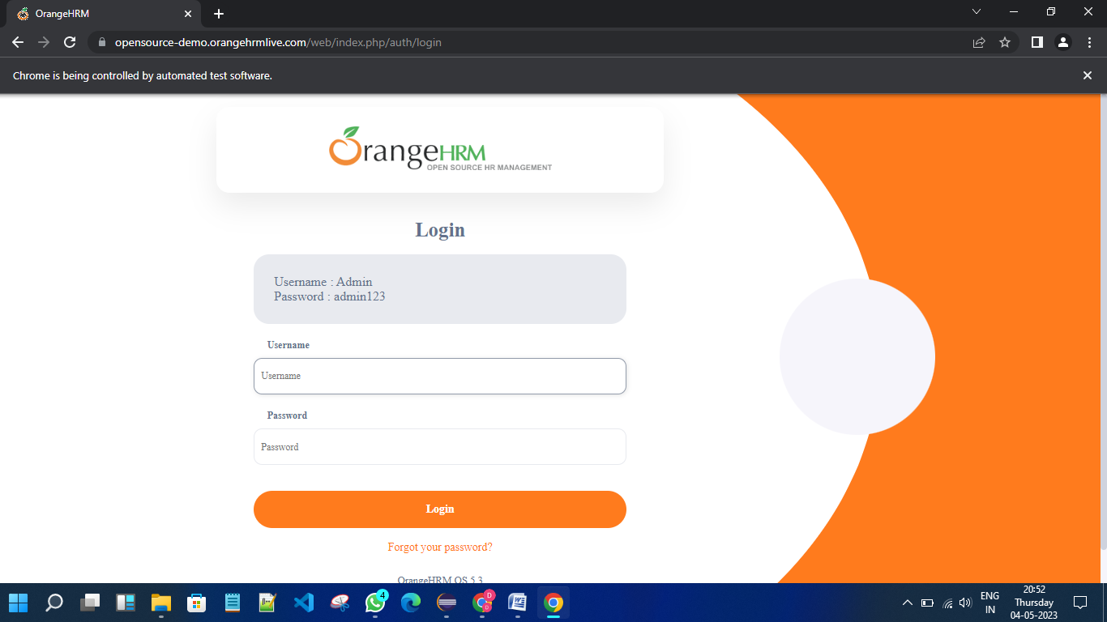

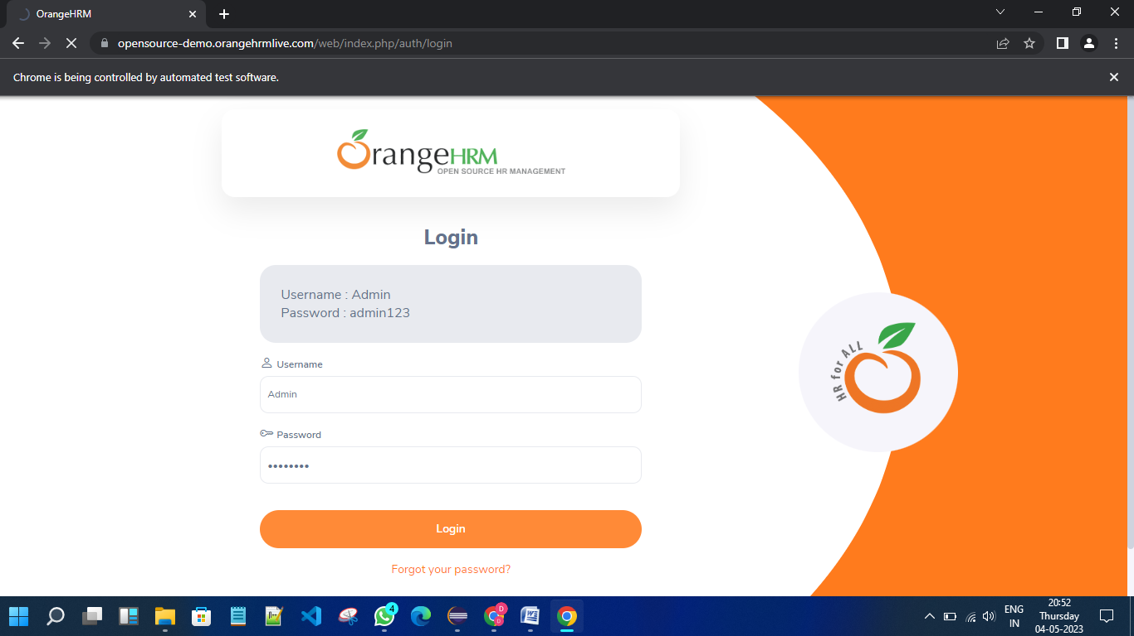

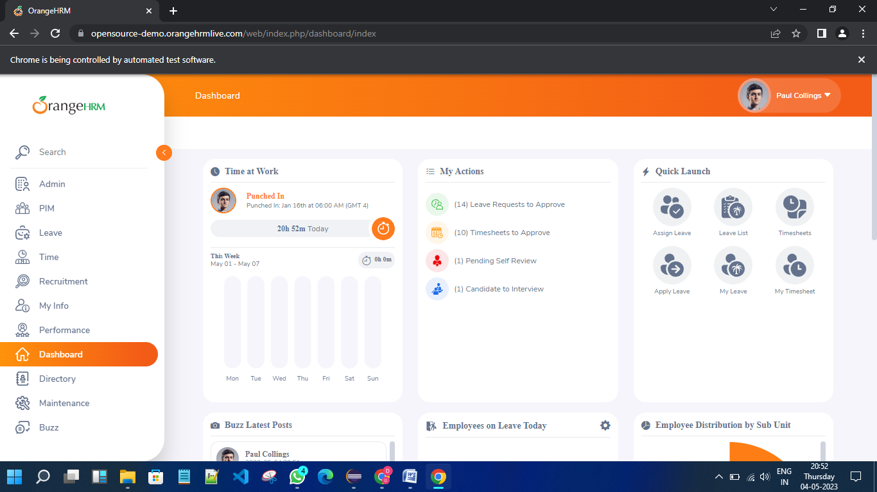

**TASK 04:-**

package com.day7;

import org.openqa.selenium.By;

import org.openqa.selenium.WebDriver;

import org.openqa.selenium.WebElement;

import org.openqa.selenium.chrome.ChromeDriver;

import org.openqa.selenium.chrome.ChromeOptions;

import org.testng.Assert;

import org.testng.annotations.AfterSuite;

import org.testng.annotations.BeforeSuite;

import org.testng.annotations.Test;

public class task4 {

static WebDriver driver;

@BeforeSuite

public static void Drive() {

ChromeOptions ed= new ChromeOptions();

driver=new ChromeDriver(ed);

}

@Test

public void dotsuff() {

driver.get("https://opensource-demo.orangehrmlive.com/web/index.php/auth/login");

driver.manage().window().maximize() ;

try {

Thread.sleep(3000);

} catch (InterruptedException e) {

e.printStackTrace();

}

WebElement uname=driver.findElement(By.name("username"));

WebElement pword=driver.findElement(By.name("password"));

WebElement submit=driver.findElement(By.xpath("//*[@id=\"app\"]/div[1]/div/div[1]/div/div[2]/div[2]/form/div[3]/button"));

uname.sendKeys("Admin");

pword.sendKeys("admin123");

submit.click();

String expecturl="https://opensource-demo.orangehrmlive.com/web/index.php/dashboard/index";

String curl=driver.getCurrentUrl();

Assert.assertEquals(expecturl, curl);

try {

Thread.sleep(5000);

} catch (InterruptedException e) {

// TODO Auto-generated catch block

e.printStackTrace();

}

}

@Test(dependsOnMethods = "dotsuff")

void distuff() throws InterruptedException {

WebElement profile=driver.findElement(By.className("oxd-userdropdown-name"));

profile.click();

try {

Thread.sleep(1000);

} catch (InterruptedException e) {

// TODO Auto-generated catch block

e.printStackTrace();

}

WebElement logout=driver.findElement(By.xpath("//*[@id=\"app\"]/div[1]/div[1]/header/div[1]/div[2]/ul/li/ul/li[4]/a"));

logout.click();

try {

Thread.sleep(3000);

} catch (InterruptedException e) {

e.printStackTrace();

}

String expecturl="https://opensource-demo.orangehrmlive.com/web/index.php/auth/login";

String curl=driver.getCurrentUrl();

Assert.assertEquals(expecturl, curl);

}

@AfterSuite

public void teardown() {

driver.close();

}

}

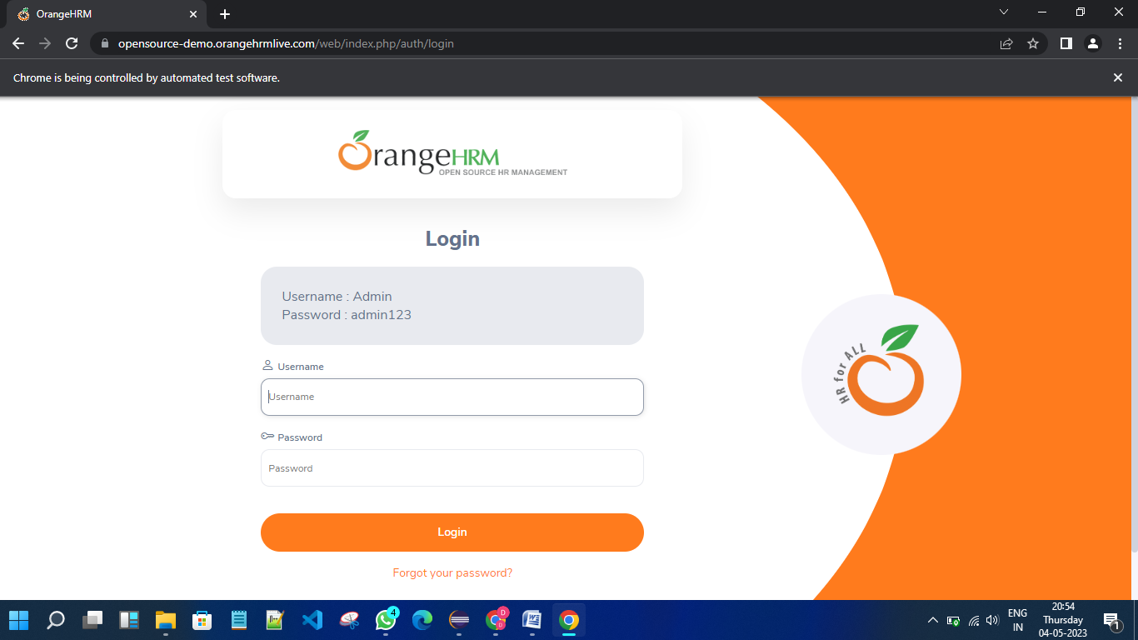

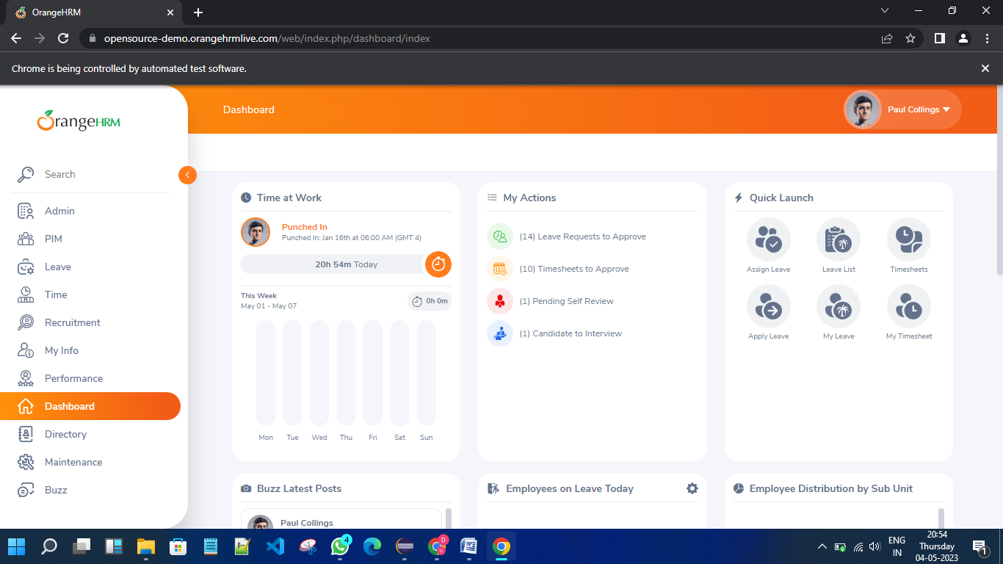

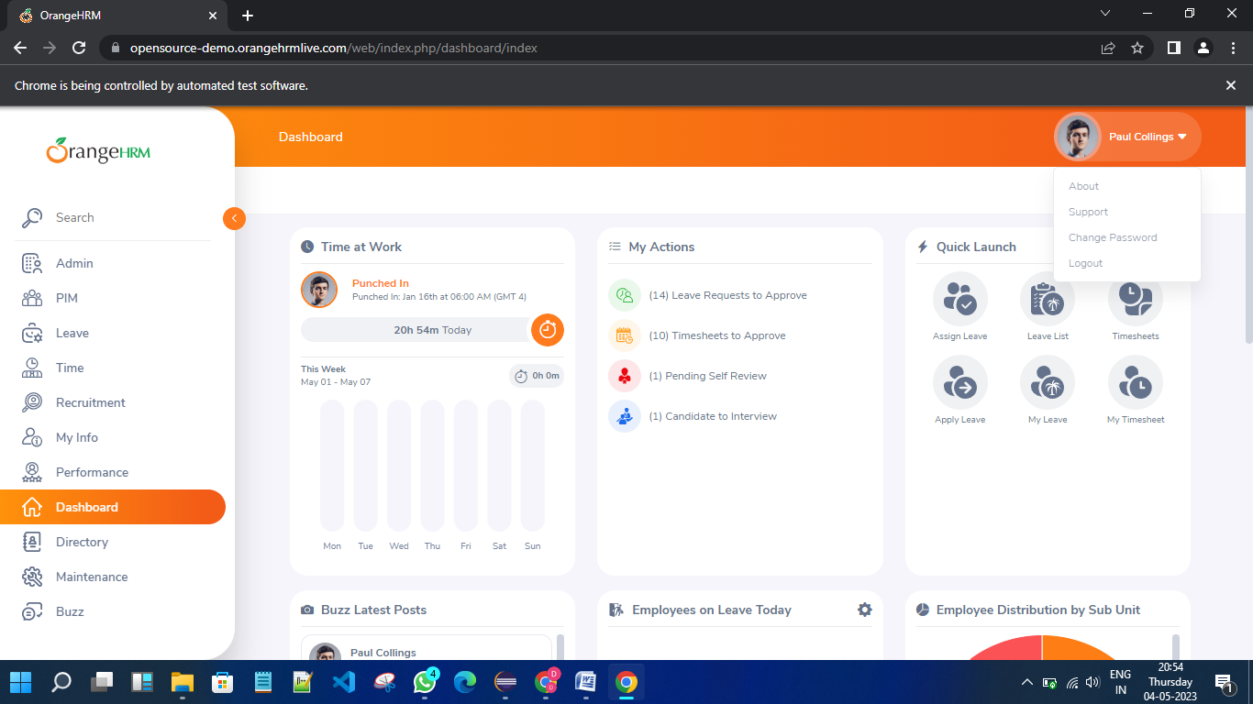

**TASK 05:-**

package com.day7;

import org.testng.annotations.Test;

import com.google.common.base.Verify;

import io.github.bonigarcia.wdm.WebDriverManager;

import java.util.concurrent.TimeUnit;

import org.openqa.selenium.By;

import org.openqa.selenium.WebDriver;

import org.openqa.selenium.WebElement;

import org.openqa.selenium.chrome.ChromeDriver;

import org.openqa.selenium.chrome.ChromeOptions;

import org.testng.Assert;

import org.testng.annotations.DataProvider;

public class task5 {

@Test

public void Testcase01() {

WebDriverManager.chromedriver().setup();

ChromeOptions ed= new ChromeOptions();

WebDriver driver=new ChromeDriver(ed);

driver.get("https://www.godaddy.com");

driver.manage().window().maximize();

Assert.assertEquals(driver.getTitle(),"Domain Names, Websites, Hosting & Online Marketing Tools - GoDaddy IN");

Assert.assertEquals(driver.getCurrentUrl(),"https://www.godaddy.com/en-in" );

}

@Test

public void Testcase02() {

WebDriverManager.chromedriver().setup();

ChromeOptions ed= new ChromeOptions();

WebDriver driver=new ChromeDriver(ed);

driver.get("https://www.godaddy.com");

driver.manage().window().maximize();

driver.manage().timeouts().implicitlyWait(5, TimeUnit.SECONDS);

driver.findElement(By.xpath("//*[@id=\"id-631b049a-e9c0-4d24-8710-c504745206dd\"]/div[2]/div[1]/ul/li[1]/button")).click();

try {

Thread.sleep(2000);

} catch (InterruptedException e) {

// TODO Auto-generated catch block

e.printStackTrace();

}

driver.findElement(By.xpath("//*[@id=\"id-631b049a-e9c0-4d24-8710-c504745206dd\"]/div[2]/div[1]/ul/li[1]/div/div[2]/div[1]/ul/li[2]/a")).click();

}

@Test

public void Testcase03() {

WebDriverManager.chromedriver().setup();

ChromeOptions ed= new ChromeOptions();

WebDriver driver=new ChromeDriver(ed);

driver.get("https://www.godaddy.com");

driver.manage().window().maximize();

driver.manage().timeouts().implicitlyWait(5, TimeUnit.SECONDS);

driver.findElement(By.xpath("//*[@id=\"id-631b049a-e9c0-4d24-8710-c504745206dd\"]/div[2]/div[1]/ul/li[1]/button")).click();

try {

Thread.sleep(2000);

} catch (InterruptedException e) {

// TODO Auto-generated catch block

e.printStackTrace();

}

driver.findElement(By.xpath("//*[@id=\"id-631b049a-e9c0-4d24-8710-c504745206dd\"]/div[2]/div[1]/ul/li[1]/div/div[2]/div[1]/ul/li[2]/a")).click();

try {

Thread.sleep(4000);

} catch (InterruptedException e) {

// TODO Auto-generated catch block

e.printStackTrace();

}

System.out.println(driver.getTitle());

if(driver.getTitle().equals("GoDaddy Domain Search - Buy and Register Available Domain Names")) {

WebElement search= driver.findElement(By.name("searchText"));

System.out.println(search.isDisplayed());

System.out.println(search.isEnabled());

WebElement buyit=driver.findElement(By.xpath("//*[@id=\"id-1467954b-c5e3-4b0c-9046-9fc94d8ca892\"]/section/div/div/section/div/div[1]/div/div/div[2]/button"));

System.out.println(buyit.isDisplayed());

System.out.println(buyit.isEnabled());

search.sendKeys("monkyhomie");

try {

Thread.sleep(2000);

} catch (InterruptedException e) {

// TODO Auto-generated catch block

e.printStackTrace();

}

buyit.click();

try {

Thread.sleep(6000);

} catch (InterruptedException e) {

// TODO Auto-generated catch block

e.printStackTrace();

}

Assert.assertEquals(driver.findElement(By.xpath("//*[@id=\"search-app\"]/div/div/div/div[2]/div[1]/div[2]/div[1]/div[2]/div/div[1]/span")).getText(),"EXACT MATCH");

Verify.verify((driver.findElement(By.xpath("//*[@id=\"search-app\"]/div/div/div/div[2]/div[1]/div[2]/div[1]/div[2]/div/div[4]/div/div/div/div[2]/button")).getText()).equals("Add to Cart"));

Verify.verify(driver.findElement(By.xpath("//*[@id=\"search-app\"]/div/div/div/div[2]/div[1]/div[2]/div[1]/div[2]/div/div[3]/div/div[1]/div[1]/div/span[1]/span")).isDisplayed());

}

else Assert.assertTrue(false);

}

}

